**Question 1**

1. Layered protocol architectures are used in communications network designs. Why?

[4 marks]

1.explicit structure allows identification, relationship of complex system’s pieces

2. layered reference model for discussion

3.modularization eases maintenance, updating of system

4.change of implementation of layer’s service transparent to rest of system

GPT：

1.Layered protocol architectures simplify network design and troubleshooting, and allow for easier implementation and maintenance.

2.They enable interoperability among different system components and vendors.

3.The layered approach allows for specialization of functions at each layer, ensuring efficient data handling.

4.Each layer in these architectures operates independently, providing modularity and flexibility in network design.

1. List and describe disadvantages of using a layered protocol architecture in the design of a communications system.

[2 marks]

The complexity of the system might increase due to the number of layers and interactions between them.

Overhead can be introduced with each layer, potentially impacting system performance.

The rigid structure of layering can sometimes limit the flexibility of the network to adapt to new technologies or protocols.

1. The International standards organisation (ISO) open systems interconnect (OSI) model is the generic architecture which is referred to worldwide. Name the layers, in the correct order of this architecture and give a key function performed at each layer.

[8 marks]

* + 7. Application layer.
    - Platform for applications.
  + 6. Presentation layer,
    - Allow general solution to regular problems.
  + 5. Session layer,
    - Establish a ‘session’ between ends.
  + 4. Transport layer,
    - Underpins many functions providing end-to-end connection.
  + 3. Network layer,
    - Concerned with controlling operation of the subnet.
  + 2. Data Link Layer,
    - Take raw transmission facility and make it free of undetected transmission errors. Provide medium access control.
  + 1. Physical layer,
    - Mechanical, Electrical, Functional & Procedural.

1. Describe the main architectural differences between the ISO/OSI open systems interconnect architecture and the TCP/IP architecture.

[3 marks]

Layers: ISO/OSI has seven layers; TCP/IP has four.

Development: ISO/OSI is theoretical; TCP/IP is practical.

Layer Functions: ISO/OSI has distinct session and presentation layers, which TCP/IP lacks.

Adoption: ISO/OSI for universal standard; TCP/IP for practical internet use.

1. Describe the advantages and disadvantages of adherence坚持 to the layering model in the TCP/IP architecture as compared to the ISO/OSI open systems interconnect architecture.

[3 marks]

Advantage

1.Adherence gives a clear demarcation between the protocols and parameters in different layers.

2.Lack of adherence can cause problems e.g. use of Port numbers (transport layer parameters) in network layer can mean interchange of transport or network layer protocols is difficult.

Disadvantage：

3.Alternatively a lack of adherence can mean that a quick fix is possible which may prove very

**Question 2**

This question is about the Internet Protocol, IP.

1. What does an IP address refer to?

[1 mark]

IP address refers to a unique numerical label in the Internet Protocol (IP) network, used to identify and locate each device (such as computers, routers).

This address allows devices in the network to recognize and communicate with each other.

An interface.

1. ‘128.85.170.3’ is a IPv4 Internet address expressed in dotted decimal notation. Give the binary equivalent of this address.

[1 mark]

10000000 01010101 10101010 00000011

170=128+42=128+32+10=128+32+8+2

1. What is the binary equivalent of the following IPv6 address: ‘FFFF**::**5050**:**A0A**:**’

[1 mark]

F-15

0000000000000000:0000000000000000:0000000000000000:1111111111111111:0000000000000000:010100000101:1010000010100000:0000000000000000

The Internet Protocol is currently moving from version 4 to version 6.

1. List the improvements offered by IPv6 as compared to IPv4.

[7 marks]

1. Increased address space.

2. Hierachical addressing.

3. Simplified header.

4. Improved security.

5. Autoconfiguration facility.

6. QoS guarantees.

7. Support of mobile computing

During the transition period both IPv4 and IPv6 need to function on the Internet simultaneously.

1. How does a packet indicate that it needs to be processed as IPv4 or IPv6?

[1 mark]

Through the contents of the (4-bit) version field.

In an IPv4 packet, this version field is set to 4.

In an IPv6 packet, this version field is set to 6.

1. How can different IPv4 and IPv6 hosts both communicate with a single server?

[2 marks]

The server is set up to run both IPv4 & IPv6 and according to version field selects which version of IP to use on a particular packet.

1. How can two different hosts running only IPv6 communicate with one another across sections of the Internet which only use IPv4?

[2 marks]

The IPv6 packets are contained within the IPv4 packets. This is provided by having IPv6/IPv4 gateways to generate the IPv4 packets and the packets then ‘tunnel’ through the IPv4 network.

1. Describe why two ways are needed for an IPv6 host to communicate with an IPv4 host and describe how these function.

[5 marks]

Conversion/translation can take place either at the network layer, but then for example addresses contained inside the data field would be problematic so conversion at this layer would not always be satisfactory OR at the application layer in which case a very complicated translation function would need to be provided but would need to be designed to deal with all cases.

**Question 3**

1. In the operation of TCP what is the objective of Flow Control and what particular parameters does TCP use to provide it?

[3 marks]

TCP uses acknowledgements of correctly received segments (i.e. no detected errors and in order delivery of all) and sequence numbers for identification. The objective of flow control in TCP is to avoid packets overwhelming the transport layer receive buffer.

1. TCP provides Flow Control and Congestion Control. How do the objectives of Flow Control and Congestion Control differ?

[4 marks]

Flow control aims to avoid a transmitter overwhelming a slower receiver i.e. data being lost because it is arriving at a receiver buffer more quickly than an application is extracting it, i.e. fundamentally across a single end-to-end link. Whereas, congestion control is to avoid the traffic arriving at routers overwhelming the input buffers and being lost through discard. This is done by reducing the rate at which traffic is transmitted. This aims to ensure the total aggregate traffic entering a network is less than the traffic leaving the network, i.e. fundamentally a network wide process.

1. Using the ‘stop and wait’ Flow Control mechanism explain (with the aid of diagrams) how the loss of a corrupted information segment can be overcome.

[2 marks]

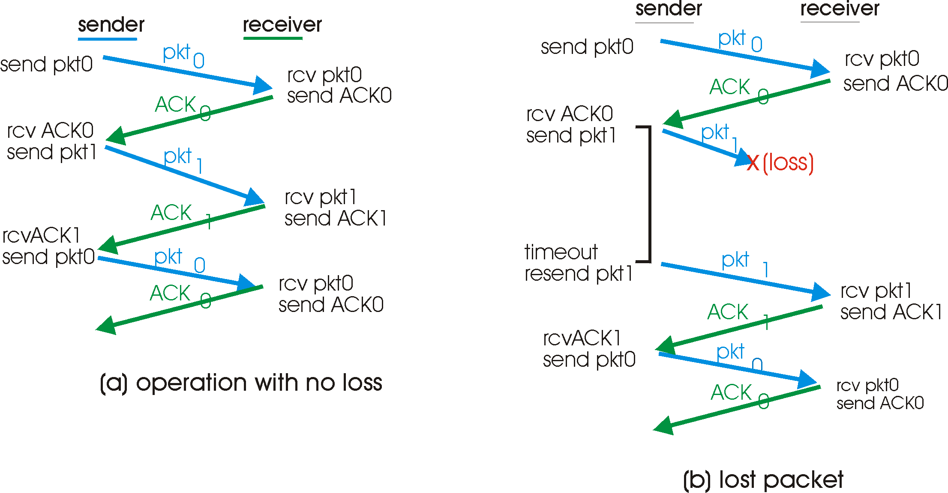

1. Using the ‘stop and wait’ Flow Control mechanism explain (with the aid of diagrams) how the loss of a corrupted acknowledgement segment can be overcome.

[2 marks]

1. 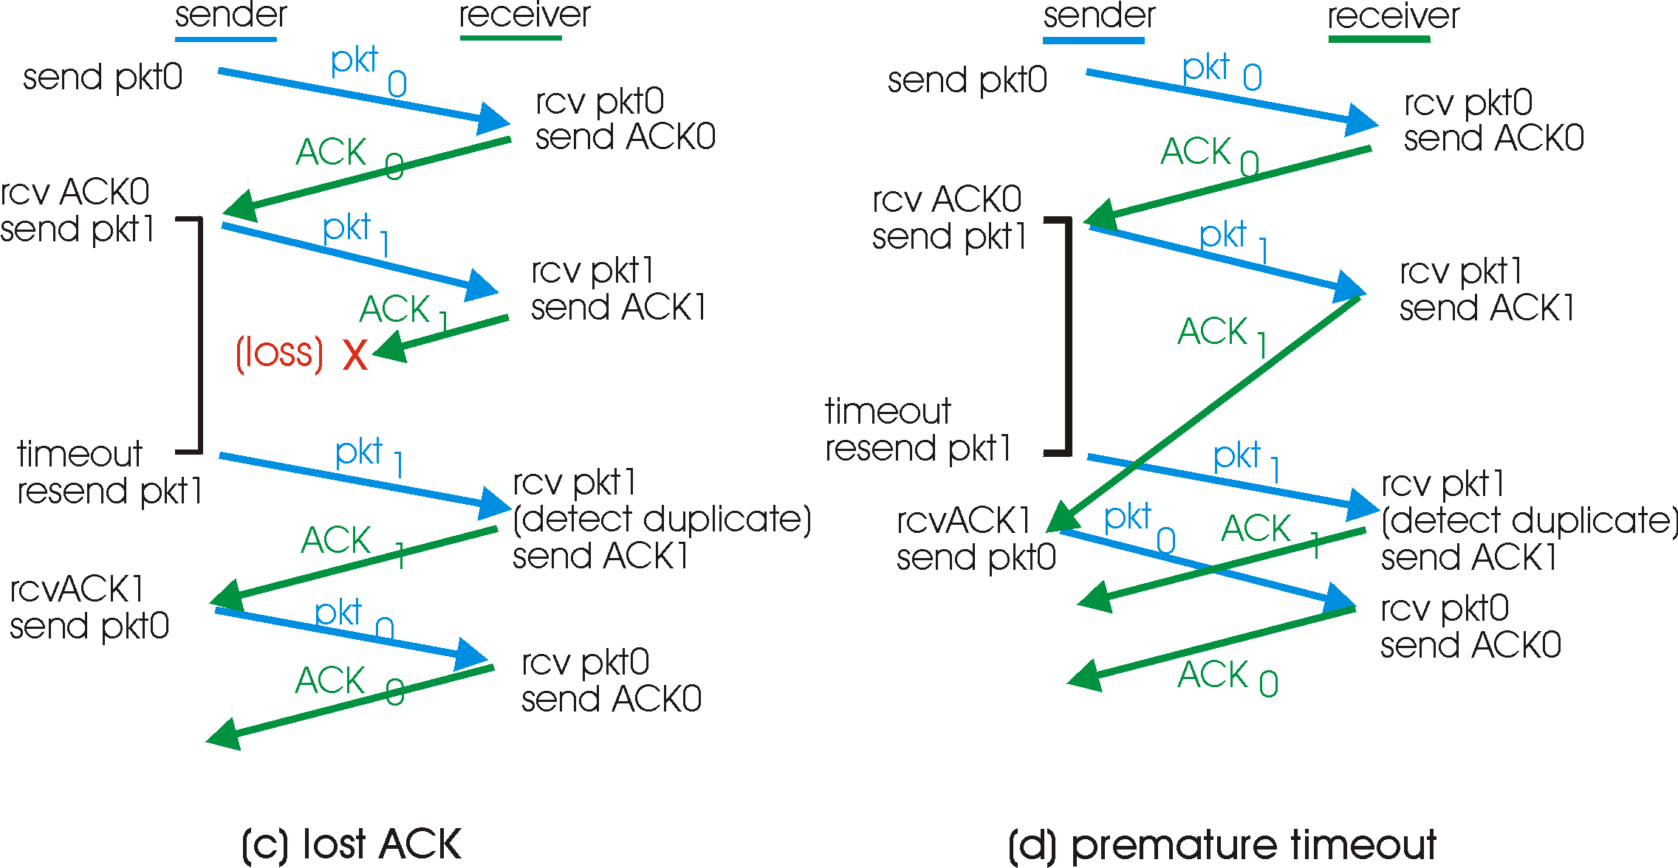A series of information frames of length 125 Bytes are transmitted over the following links using the ‘stop and wait’ Flow Control mechanism. The velocity of propagation across these links is 2 x 108 m.s-1. For each link determine the link efficiency.
2. a 1000 km link with a data transmission rate of 1 Gbps.

[3 marks]

Link Efficiency, U = {L/R}/ [RTT+ {L/R}]

L = 125B = 1000b, d=2x106m

{L/R} = 1x10-6s, RTT={2x106 /2x108} = 1x10-2.

U = {1x10-6}/{1x10-2 + 1x10-6} = ~1x10-4 ~ 0.01%]

1. a 10m link with a transmission rate of 1 Mbps.

[3 marks]

L =125B =1000b, d = 20m, R = 1x106bps,

{L/R} = 1 x 10-3, RTT = 20/2x108 = 1x10-7

U = 1x10-3/{1x10-3+1x10-7} = ~1 ~100%

1. Comment on this result and use a table to compare alternative flow control mechanisms. Include the advantages and disadvantages of each mechanism in your table.

[3 marks]

Fundamentally for short links where the passage of the data is filling the link stop and wait is very efficient e.g. Bluetooth.

However for larger and faster networks where the RTT is significant and the data are not continuous across the link stop and wait is highly inefficient.

In these cases go back n or selective repeat are better but each have particular storage requirements.

**Question 4**

1. Describe the Internet data transfer service offered by TCP.

[3 marks]

TCP provides a reliable data transfer service i.e. in order delivery of all data.

1. Describe the Internet data transfer service offered by UDP.

[2 marks]

UDP provides a best effort service, i.e. it simply provides unenhanced the service of the network layer below, i.e. it provides multiplexing and limited error detection.

1. Since both TCP and UDP provide their services using the same layer below. Describe how the difference in service provided by TCP, as compared to UDP, is achieved and any parameters used in provision.

[5 marks]

Both TCP and UDP are using IP [1] but TCP uses sequence numbers [1] (so segments can be reordered is necessary [1]), acknowledgements [1] and retransmission of missing segments [1].

1. Describe the process within the TCP entity of establishing a TCP connection.

[6 marks]

1. The transport layer (TCP) entity within the host machine trying to establish a connection sends a segment with the SYN bit high and a random initial sequence number (X) to the host which the connection is to be made with.

2. The TCP entity within the destination host acknowledges the received SYN packet whilst holding SYN high, random initial sequence number (Y) ACK high and Acknowledgement number X+1.

3. The origin of the request then acknowledges the returned packed and the connection is established. ACK=1, Ack = Y+1.

i.e. a 3 way handshake.

1. What applications might chose to use UDP and why?

[4 marks]

Any applications which are more sensitive to time delays than errors might choose to use UDP since the congestion control and flow control mechanisms of TCP can lead to increased and variable delays of packets but data carried by UDP is likely to have more errors.

**The End**